**FlowChart User-Role:**

* The user starts on the homepage
* From the homepage the user clicks login
* From the category page the user clicks Admin/login
* From the main page the update/add new User
* From the main page the user adds/delete the roles
* From the main page the user update/create the roles
* From the Role the user checks out all roles.

**1. Table shown complete mapping of user and role:**

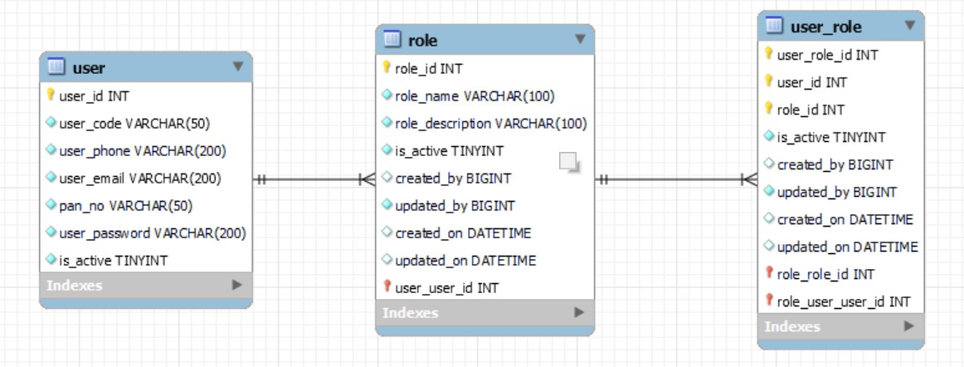

**2. FlowChart**

